CHRIS WATSON TRAVEL – CMC ROCKS 2022
BOOKING FORM – 1 PER ROOM
For Internal Use
BOOKING NUMBER
AGENT

Clients – Please fill out the below:
Hotel Preference:
Rooming: | ☐ Single ☐ Queen/King  ☐ Twin (Requesting 2 beds) ☐ Triple  ☐ Quad
Package inclusions: | ☐ Full 4 night tour package  ☐ Room Only ☐ Room & Tickets ☐ Room Tickets & Shuttle  ☐ Please quote flights
Please quote flights from:

PASSENGER 1 DETAILS (EXACTLY as per ID)
TITLE | ☐ MR ☐ MRS ☐ MS ☐ MISS
FIRST NAME
SURNAME
ADDRESS
SUBURB
STATE
POSTCODE
MOBILE
EMAIL
VACCINATION STATUS

PASSENGER 2 DETAILS (EXACTLY as per ID)
TITLE | ☐ MR ☐ MRS ☐ MS ☐ MISS
FIRST NAME
SURNAME
MOBILE
EMAIL
VACCINATION STATUS

PASSENGER 3 DETAILS (EXACTLY as per ID)
TITLE | ☐ MR ☐ MRS ☐ MS ☐ MISS
FIRST NAME
SURNAME
MOBILE
EMAIL
VACCINATION STATUS

PASSENGER 4 DETAILS (EXACTLY as per ID)
TITLE | ☐ MR ☐ MRS ☐ MS ☐ MISS
FIRST NAME
SURNAME
MOBILE
EMAIL
VACCINATION STATUS

ADDITIONAL INFORMATION
DIETARY REQUIREMENTS
MOBILITY REQUIREMENTS
MEDICAL

EMERGENCY CONTACT DETAILS (not travelling companion)
NAME
RELATIONSHIP
MOBILE
EMAIL

Alterations or notes:
Notes or Changes

TRAVEL INSURANCE/VISAS
TRAVEL INSURANCE | ☐ YES ☐ NO ☐ QUOTE
PRE-EXISTING MEDICAL COND. | ☐ YES ☐ NO
OWN INSURANCE | PROVIDER:  CONTACT NUMBER:  POLICY NUMBER:
WAIVER IF NOT TA | ☐ YES ☐ NO
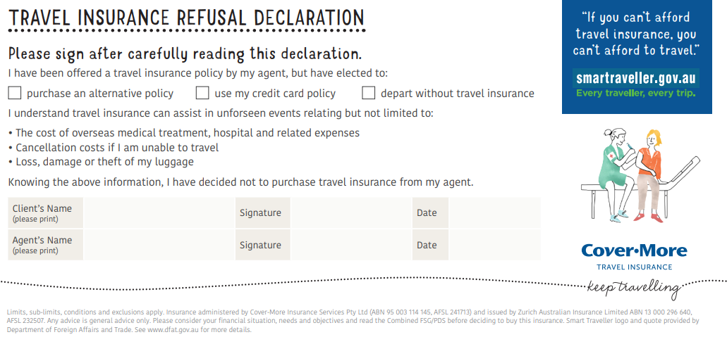

☐ Covid-19 Vaccination Certificate attached
☐ I agree to all Terms and Conditions as outline and listed at www.chriswatsontravel.com.au
☐ Rediscover Australia has advised that deposit quoted of $400 is non refundable , A credit might be able to be offered but Swish Wish Pty LTD advise Travel Insurance to protect the consumer. A credit can be offered if the event is postponed.
☐ Chris Watson Travel has advised a full comprehensive insurance policy is highly recommended at time of booking. (If this is arranged outside Chris Watson Travel will provide the policy details)
☐ I Understand name changes incur a fee.
☐ I Understand Chris Watson Travel will charge service fees for cancelled bookings.

CONDITION OF GROUP TRAVEL – CLIENTS MUST BE FULLY VACCINATED

SIGNED:__________________________________________________________________

SIGNATURE:_______________________________________________________________

SIGNED:__________________________________________________________________

SIGNATURE:_______________________________________________________________

SIGNED:__________________________________________________________________

SIGNATURE:_______________________________________________________________

SIGNED:__________________________________________________________________

SIGNATURE:_______________________________________________________________

